
Republic of the Philippines
Department of Education
National Capital Region
DIVISION OF CITY SCHOOLS
Quezon City, Metro Manila


SECOND PERIODICAL TEST
MATHEMATICS II(Mock NAT) - SY 2009-2010

DIRECTIONS: Choose the letter corresponding to the correct answer.

1. In the radical expression 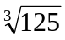, what does 125 stand for?
A. index B. radicand C. exponent D. coefficient

2. What is the simplest form of the radical expression 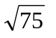?
A. 5 B. 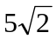 C. 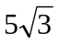 D. 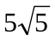

3. Find the sum of the expression : 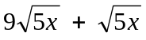 .
A. 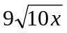 B. 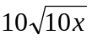 C. 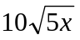 D. 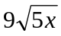

4. What is the point of intersection of the linear function 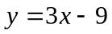 and the y-axis ?
A. 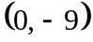 B. 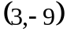 C.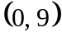 D. 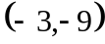

5. Which of the following defines a polynomial?
A. x B.  C. 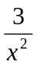 D. 

6. Simplify the expression 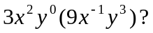
A. 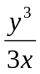 B. 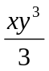 C. 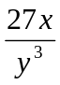 D. 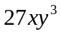

7. Evaluate: 2⁴ 3²

A. 30 B. 48 C. 96 D. 144

8. Which of the following polynomial is a trinomial ?
A. 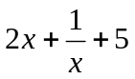 B. 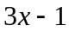 C. 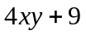 D. 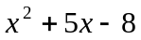
9. What is the combined form of  + 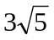 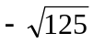 ?

A. B. 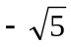 C. D. 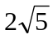

10. Which of the following systems of linear equations represent parallel lines?
A. 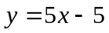 B. 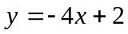 C. 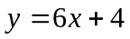 D. 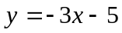
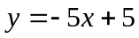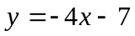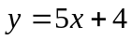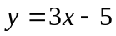
11. If the domain is the set 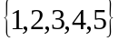, what is the solution set of 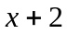 > 4 ?
A. 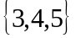 B. 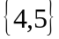 C. 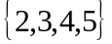 D.

12. What is the factored form of the quadratic equation 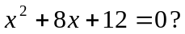

A. (x+2)(x+6) = 0 C. (x + 4)(x + 3) = 0
B. (x-2)(x-6) = 0 D. (x+1)(x+12) = 0

13. When factored, what is the solution set of the quadratic equation 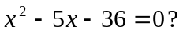
A. {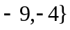 B. {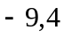} C. {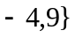 D. {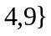

14. When 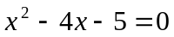 is solved using completing the square, what equation is obtained and what are
the solutions?
A. (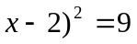 C. (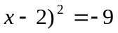
Solutions: { , 5 } Solutions: no solutions
B. 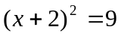 D. (
Solutions: { 1, 5 } Solutions: { 1, 5 }

15. What is the 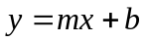 form of the equation defined as 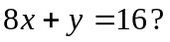
A. 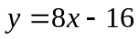 B. 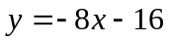 C. 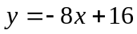 D. 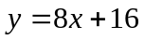

16. Solve the quadratic equation 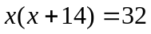.
A. x = 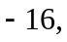x = 2 C. 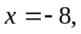 x = 4
B. x = 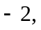 x = 16 D. 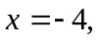x = 8

17. What is the slope of a line passing through the points 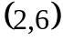 and 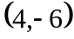 ?
A. 0 B. – 6 C. 6 D. – 2

18. What is the sum of the roots of 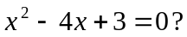
A. −3 B. – 4 C. 3 D. 4
19. When written in 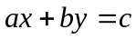 form, the linear equation 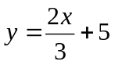 is equivalent to
A. 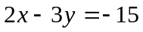 B. 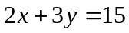 C. 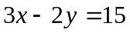 D. 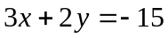

20. Solve the quadratic equation 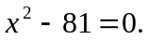
A. 9 B. – 9 C. 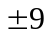 D. 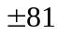

21. If a line passing through the points 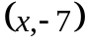 and 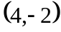 has a slope of 5, what is the value of x?
A. 5 B. – 5 C. 3 D. – 3

22. Perform the indicated operation: ( 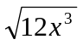)( 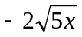).
A. 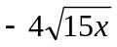 B. 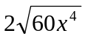 C. 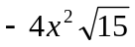 D. 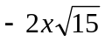
23. What is the equation of a line perpendicular to the line 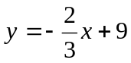 if its y-intercept is 5?
A. 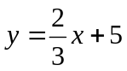 B. 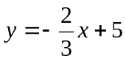 C. 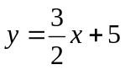 D. 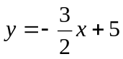
24. Find the roots of the quadratic equation 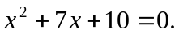
A. { 7, −10} B. { − 5 , 3 } C. { −2 , 5 } D. { −2, −5 }

25. Which of the following systems of linear equations has the point ( 4,3) as the solution set.
A. 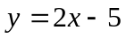 B. 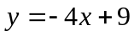 C. D.
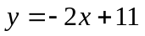
26. What is the simplest form of the radical expression 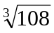 ?
A. 6 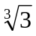 B. 3 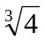 C. 4 D. 6

27. The sum of two numbers is 27 and their difference is 3. Which system of linear equations satisfies
the given conditions?
A. x + y = 27 and x – y = 3 C. x – y = 27 and x + y = 3
B. 3x + y= 24 and x – y = 3 D. 3x – y = 24 and x + y = 3

28. What is the combined form of the rational expressions 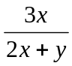 and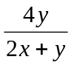?

A. 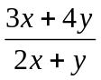 B. 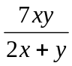 C. 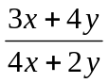 D. 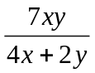

29. The width of a conference room is 5 meters less than its length. If the area of the room is 84 sq. m,
what is the equation representing its area?
A. 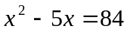 C. 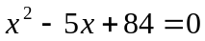
B. 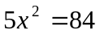 D. 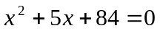

30. What is the width in meters of the conference room described in number 29?
A. 5 B. 7 C. 10 D. 12

31. How long in meters is the conference room in number 29?
A. 7 B. 10 C. 12 D. 15

32. What is the equation of a line whose x- and y- intercepts are – 4 and 5, respectively?
A. 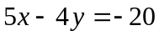 B. 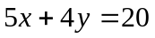 C. 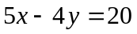 D. 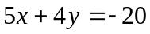

33. If the slope and a point are given, which one will define the equation satisfying the conditions?
A. 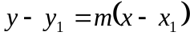 C. 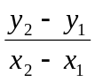
B. 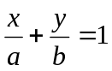 D.
34. If the roots of a quadratic equation are 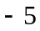 and 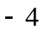, what is its defining equation in factored form?
A. ( x + 5)(x – 4 ) = 0 C. ( x + 5)(x + 4) = 0
B. ( x – 5 )(x + 4 ) = 0 D. (x – 5 )( x – 4 ) = 0

35.When the value of y in Equation 2 below is substituted in Equation 1, what is the resulting equation?
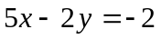 ( Equation 1)
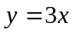 ( Equation 2 )
A. 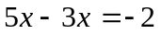 B. 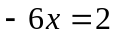 C. 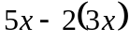 = 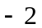 D. 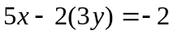

36. What values of m and n will make both of the following equations true if m is eliminated
in both of them ?
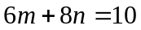
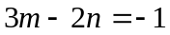
A. 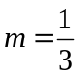 and 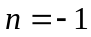 C. 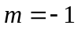 and 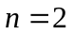
B. 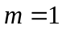 and 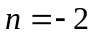 D. and 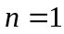
37. Which of the following is the simplest form of the rational expression 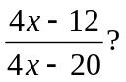
A. 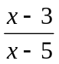 B. 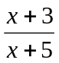 C. 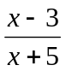 D. 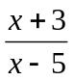

38. What is the common monomial factor of the numerator and the denominator of the rational expression in
number 37?
A. 4 B. – 4 C. 4x D. 3x

39. What value of x will make the rational expression in number 37 undefined or meaningless?
A. 4 B. 5 C. – 4 D. – 5
40. Write in simplest form: 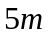 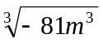.
A. 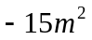 B. 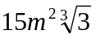 C. 45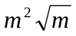 D. - 45

41. Perform the indicated operation : 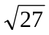 + 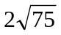 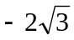.
A.  B. 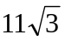 C. 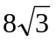 D. 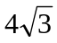

42. What is the simplified form of 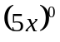 ?
A. 5 B. x C. 1 D. 0

43. If 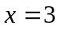 and , what is the value of the expression 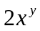?
A. 0 B. 1 C. 2 D. 6

44. Simplify : 2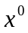 ÷ 2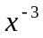
A. 1 B. 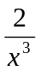 C. 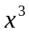 D. 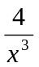
45. Which of the following is the correct translation of the phrase “ the square of x divided by the cube of y” ?
A. (x/y)² B. (x/y)³ C. 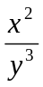 D. 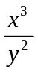
46. The product of two consecutive positive odd integers is 195. What is the larger integer? .
A. 12 B. 13 C. 14 D. 15

47. John has 120 meters of fencing materials. He wants to fence his vegetable garden with it. What is the maximum area of the garden in sq m which he can fence ?
A. 800 B. 850 C. 900 D. 950

48. If the square root of the cube root of N is equal to 3, what is the value of N?
A. 9 B. 27 C. 81 D. 729

49. The legs of a right triangle has lengths ( 4 + ) and ( 4 ) meters . How long is the hypotenuse?

A. 36 B. 60 C. 6 D. 360

50. Which of the following radical expressions is the rationalized form of 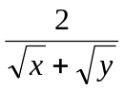?
A. 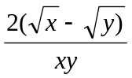 C. 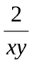

B. 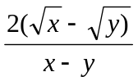 D. 